

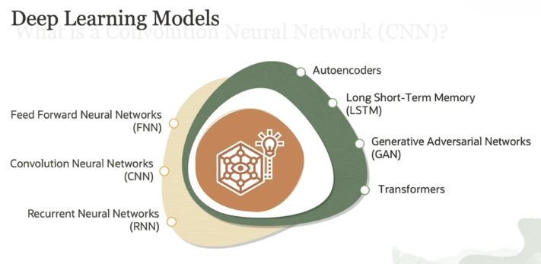

**1. Feedforward Neural Networks (FNN) / Multilayer Perceptron (MLP):**

* **What is it?**  
  This is the **simplest type of neural network**. The data flows in one direction—from input to output—through multiple layers of neurons. It doesn’t loop back or have memory, so it’s great for tasks where you don’t need to remember past information, like basic classification.
* **Example:**  
  Classifying whether an image contains a cat or a dog based only on the current image.

**2. Convolutional Neural Networks (CNN):**

* **What is it?**  
  CNNs are designed for **image and video processing**. They automatically learn to detect important local patterns, such as edges, textures, and shapes, without manual intervention. CNNs are widely used for tasks like object detection and facial recognition.
* **Example:**  
  Detecting whether an image contains a person’s face or identifying objects in a video.

**3. Recurrent Neural Networks (RNN):**

* **What is it?**  
  RNNs are designed to work with **sequential data**—data that has a time element or order. They have a feedback loop that allows them to keep a memory of previous information, which makes them suitable for tasks like predicting the next word in a sentence.
* **Example:**  
  Predicting the next word while typing a sentence or analyzing a sequence of stock prices over time.

**4. Autoencoders:**

* **What is it?**  
  Autoencoders are **unsupervised learning models** used mainly for compressing data or identifying anomalies. They work by reducing data to a smaller size (dimensionality reduction), while still keeping the essential features, then recreating it. They are used in tasks like data compression or detecting unusual patterns.
* **Example:**  
  Compressing an image into a smaller size or detecting fraud by finding irregular patterns in financial data.

**5. Long Short-Term Memory (LSTM):**

* **What is it?**  
  LSTMs are a special type of **RNN** designed to remember information over long sequences and handle **long-term dependencies**. They are very good at understanding sequences, such as sentences in text or long time-series data.
* **Example:**  
  Generating text based on a long sequence of previous words or predicting the future value of a stock based on a long historical trend.

**6. Generative Adversarial Networks (GAN):**

* **What is it?**  
  GANs consist of two neural networks competing with each other—a **generator** and a **discriminator**. The generator creates fake data (like images), and the discriminator tries to detect if it's fake or real. Over time, the generator becomes better at producing realistic data. GANs are used to generate synthetic data like images, music, or text.
* **Example:**  
  Creating realistic-looking images of people who don’t exist or generating music that sounds like it was composed by a human.

**7. Transformers:**

* **What is it?**  
  **Transformers** are the current state-of-the-art models in **Natural Language Processing (NLP)**. Unlike RNNs, they process entire sequences of data in parallel, making them faster and better at handling long-range dependencies. They are widely used for tasks like machine translation, text generation, and understanding the meaning of sentences.
* **Example:**  
  **GPT (Generative Pre-trained Transformer)**, like the one used here, is a transformer-based model that can generate human-like text, translate languages, or answer questions.

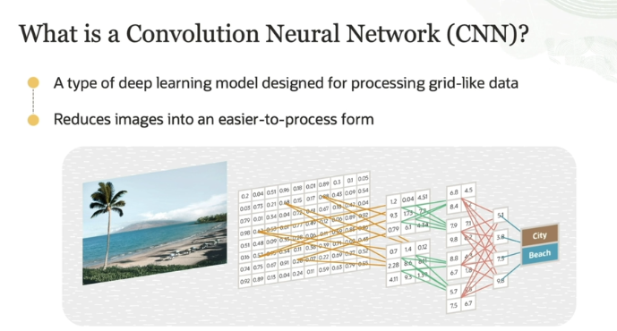

**What is a CNN?**

* **CNN** is a **type of deep learning model** specifically designed for **processing grid-like data** such as **images and videos**.
* It works by reducing images into an **easier-to-process form** while still retaining the most important features.

**Why is CNN better for image data than traditional neural networks (ANNs)?**

* In a traditional **Artificial Neural Network (ANN)**, image data is flattened into a **one-dimensional array** (a long list of pixels) before being fed into the network. However, this loses the **spatial relationships** between pixels (like edges, textures, or patterns).
* Image data is naturally **two-dimensional**, and CNNs are designed to **preserve these 2D features** (such as nearby pixels or patterns), making them more effective for analyzing visual data.

**How does CNN process images?**

* As shown in the picture, the CNN:
  1. **Takes the input image** (for example, a beach scene).
  2. Breaks it into smaller pieces (also called **filters or kernels**) that scan across the image to detect important features like edges, colors, and textures.
  3. These pieces of the image are represented as a **grid of numbers** (pixel values), and CNN uses mathematical operations (convolutions) to detect patterns.
  4. The network gradually **reduces the complexity** of the image through pooling layers, which combine similar pixels, to make the image easier to process.
* Finally, the CNN **classifies the image** based on the features it has learned. For example, in the image, it might recognize that the scene is of a **beach** rather than a **city**, based on the features it extracted.

**Key Takeaway:**

CNNs excel at processing and analyzing **image data** by preserving the important features while reducing the complexity of the data for easier processing. This is why CNNs are commonly used in tasks like **image classification, object detection, and facial recognition**.

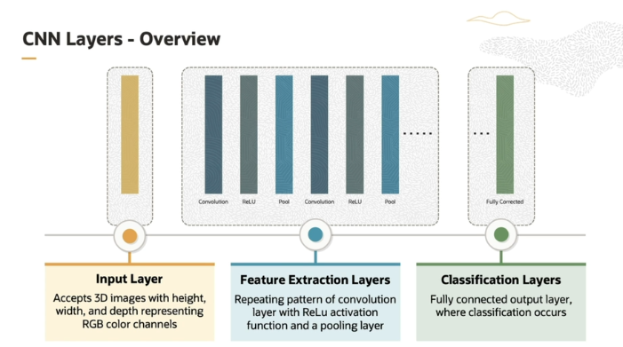

**1. Input Layer**

* This is where the **image data** is fed into the network.
* For example, if you are trying to classify an image of a cat, the raw pixel data of that image enters through this **input layer**.

**2. Feature Extraction Layers**

* These layers are responsible for **detecting important patterns** and **features** in the image, like edges, textures, and shapes.
* The feature extraction process is a **combination of multiple layers**, and it repeats several times to extract deeper and more complex features. The key components here are:

**a. Convolutional Layer**

- The **Convolutional Layer** is where the real magic happens. It slides small filters (like a moving window) over the image to detect specific patterns (e.g., edges or corners).

- **ReLU Activation** is applied here to introduce **non-linearity**, which helps the network understand complex patterns, not just straight lines.

**ReLU Activation in CNNs:**

* **ReLU** stands for **Rectified Linear Unit**, and it's a type of function used in neural networks, especially in **Convolutional Neural Networks (CNNs)**.
* **Why Use ReLU?**
  + Imagine the neural network as a tool trying to learn and recognize patterns in images. If we didn’t add **ReLU** or some kind of **activation function**, the network would only be able to learn very simple things like **straight lines**. That’s like trying to understand the world using just a ruler—not very useful for real-world images that have complex shapes and patterns!
* **What Does ReLU Do?**
  + ReLU is a simple function that says: **If the value is positive, keep it. If it’s negative, set it to zero**.
  + This adds **non-linearity**. In simpler terms, it lets the network learn more complex, curvy patterns instead of just straight lines.

**Why Non-Linearity Matters:**

* **Without ReLU:** The network would be too basic, like drawing everything with straight lines.
* **With ReLU:** The network can understand more complicated shapes, like curves and edges in an image, which helps it recognize things like faces, animals, or objects.

**b. Pooling Layer**

- After the convolution, a **Pooling Layer** reduces the size of the data while keeping the important information. This process is called **down-sampling**.

- Think of it as summarizing the features detected in the convolution step, keeping only the most important parts.

**3. Classification Layer (Fully Connected Layer)**

* Once the features have been extracted, they are passed to the **classification layer**.
* Here, the network uses the extracted features to **classify the image** into different categories (output classes). For example, it could decide whether the image is a **cat, dog, or car**.
* These layers are called **fully connected** because every neuron is connected to every neuron in the previous layer, combining all the information to make the final decision.

**Key Takeaway:**

* The **input layer** takes in the raw image, the **feature extraction layers** break the image down into important parts (like edges, textures, etc.), and the **classification layer** makes the final decision about what the image represents.
* This structure makes CNNs highly effective at **image recognition and classification** tasks.

In order to understand feature extraction layers better, let us take an analogy.

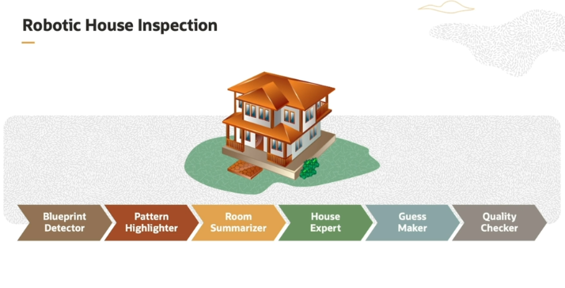

**The Robot Analogy:**

Imagine a robot inspecting a house to figure out what type of house it is. It uses a series of tools to help it analyze the house step by step. These tools represent the **layers of a CNN** that help in recognizing features in images. Here’s what each tool in the analogy means in terms of a CNN:

**1. Blueprint Detector (Convolutional Layer):**

* This tool scans different parts of the house, like walls, windows, or floors, looking for specific patterns or features.
* In CNNs, this is like the **convolutional layer**, which scans different parts of an image (like edges, textures, and colors) to detect important features, such as edges or corners.

**2. Pattern Highlighter (Activation Function, like ReLU):**

* This tool highlights the important areas detected by the blueprint detector.
* In CNNs, this is where an **activation function** (like ReLU) comes in. It helps "highlight" important patterns by making the network focus on significant features and ignore less useful information.

**3. Summariser (Pooling Layer):**

* This tool summarizes the most important features from each room, condensing them into a simpler form.
* In CNNs, this is the **pooling layer**, which reduces the size of the data while keeping the most important information. It helps the network focus on the essential features of the image and discard unnecessary details.

**4. House Expert (Fully Connected Layer):**

* The house expert looks at all the highlighted patterns and features from the entire house and tries to understand what kind of house it is.
* In CNNs, this is the **fully connected layer**, where the network combines all the information from the earlier layers to form a full understanding of the image.

**5. Guess Maker (Softmax Layer or Output Layer):**

* The guess maker assigns probabilities to the different possible house types (like "Is it a villa? Is it an apartment?").
* In CNNs, this is the **output layer**, where the network makes predictions by assigning probabilities to different classes (like cat, dog, or car).

The **Softmax layer** is typically used at the end of a neural network, especially in classification problems, where you want to assign probabilities to different classes (or categories). Let’s break it down step by step:

**What Does the Softmax Layer Do?**

1. **Converts Scores to Probabilities:**
   * Before the Softmax layer, the network gives out **raw scores** (called logits) for each possible class. These scores are not easy to interpret directly, because they could be any number, positive or negative.
   * The Softmax function takes these raw scores and **converts them into probabilities** that sum up to 1, which makes it easier to understand which class is most likely.
2. **How It Works:**
   * The Softmax function does this by:
     + Exponentiating each of the raw scores (raising the natural number eee to the power of each score).
     + Then, it **normalizes** these values by dividing each of them by the sum of all exponentiated values. This ensures that all the probabilities add up to 1.
   * Mathematically, for a class iii, the Softmax probability PiP_iPi​ is calculated as: Pi=ezi∑jezjP_i = \frac{e^{z_i}}{\sum_{j} e^{z_j}}Pi​=∑j​ezj​ezi​​ Where:
     + ziz_izi​ is the raw score for class iii.
     + The sum in the denominator is over all possible classes.

**Example to Understand Softmax:**

Imagine you're trying to classify an image as either a **cat**, **dog**, or **rabbit**. After the network processes the image, it outputs the following raw scores (logits):

* **Cat:** 2.0
* **Dog:** 1.0
* **Rabbit:** 0.1

These raw scores don’t mean much on their own, but Softmax will convert them into **probabilities**. Here’s how:

1. **Exponentiate the scores**:
   * e2.0≈7.39e^{2.0} \approx 7.39e2.0≈7.39 (for Cat)
   * e1.0≈2.72e^{1.0} \approx 2.72e1.0≈2.72 (for Dog)
   * e0.1≈1.11e^{0.1} \approx 1.11e0.1≈1.11 (for Rabbit)
2. **Sum of all exponentiated values**:
   * 7.39+2.72+1.11=11.227.39 + 2.72 + 1.11 = 11.227.39+2.72+1.11=11.22
3. **Calculate each class probability**:
   * Cat: 7.3911.22≈0.66\frac{7.39}{11.22} \approx 0.6611.227.39​≈0.66 or 66%
   * Dog: 2.7211.22≈0.24\frac{2.72}{11.22} \approx 0.2411.222.72​≈0.24 or 24%
   * Rabbit: 1.1111.22≈0.10\frac{1.11}{11.22} \approx 0.1011.221.11​≈0.10 or 10%

So, the network predicts that the image is most likely a **cat** with 66% confidence, followed by **dog** with 24%, and **rabbit** with 10%.

**Why Use Softmax?**

* It turns raw numbers into **meaningful probabilities**, making it easier to interpret which class the network thinks is most likely.
* It’s especially useful for **multi-class classification**, where you need to decide between more than two possible classes (like classifying animals, objects, etc.).

**6. Quality Checker (Dropout Layer):**

* The quality checker randomly checks different parts of the analysis to make sure the robot doesn’t rely too much on any single piece of information.
* In CNNs, this represents the **dropout layer**, which randomly ignores some neurons during training to ensure the model doesn’t over-rely on any one specific feature. This helps prevent overfitting.

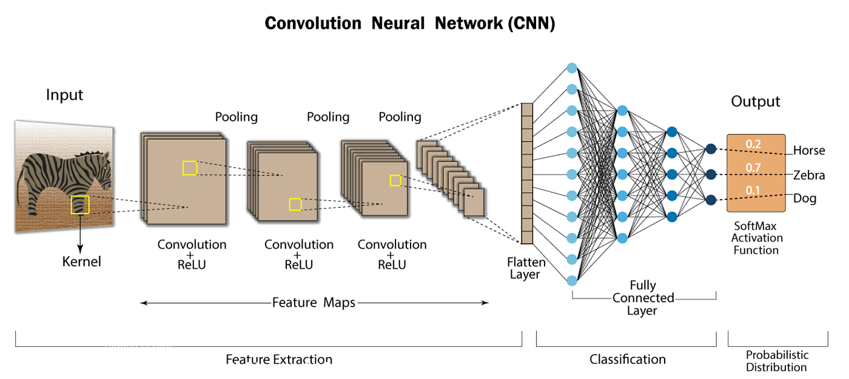

**Here is the comparison/mapping of House analogy and feature extract layer**

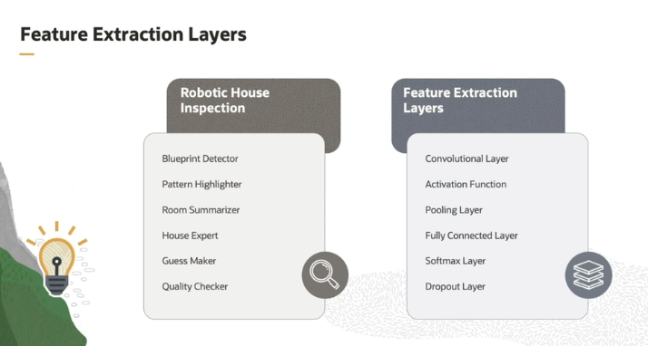

Let us see how this is mapped to the feature extraction layers.

Let us check the analogy between a robot, house inspector, and different layers of the feature extraction. Similar to blueprint detector, we have a convolutional layer. This layer applies convolutional operations to the input image using small filters known as kernels. Each filter slides across the input image to detect specific features, such as edges, corners, or textures.

Similar to pattern highlighter, we have an activation function. The activation function allows the network to learn more complex and non-linear relationships in the data. Pooling layer is similar to room summarizer. Pooling helps reduce the spatial dimensions of the feature maps generated by the convolutional layers. Similar to a house expert, we have a fully connected layer, which is responsible for making final predictions or classifications based on the learned features.

Softmax layer converts the output of the last fully connected layers into probability scores. The class with the highest probability is the predicted class. This is similar to the guessmaker. And finally, we have the dropout layer. This layer is a regularization technique used to prevent overfitting in the network. This has the same role as that of a quality checker.

**Summarization:**

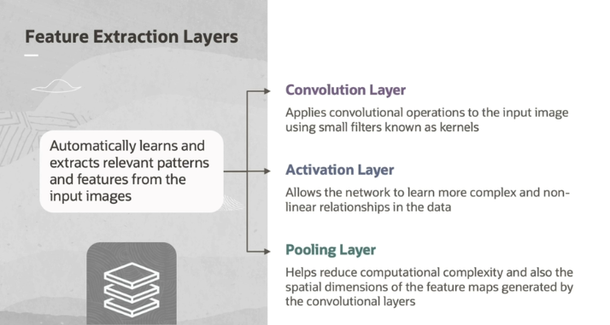

To summarize, the purpose of feature extraction layers is to automatically learn and extract relevant patterns and features from the input images. Convolutional layer applies convolutional operations to the input image using small filters known as kernels. Each filter slides across the input image to detect specific features, such as edges, corners, or textures.

The second one is the activation function, which is applied after each convolutional operation. The activation function allows the network to learn more complex and non-linear relationships in the data. And the third one is pooling. It helps reduce computational complexity and also reduces the spatial dimensions(like corner,edges) of the feature maps generated by the convolutional layers.

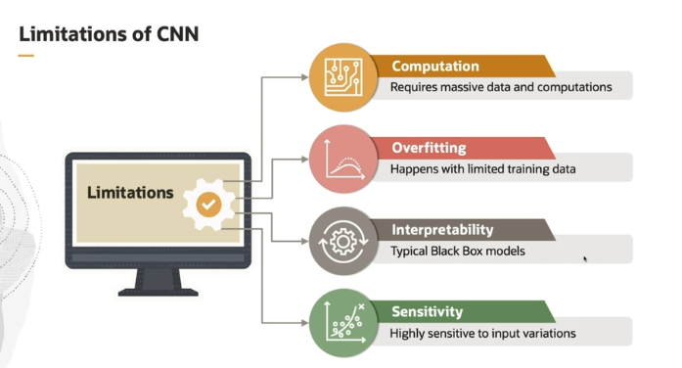

**1. Computation:**

* **Explanation**: CNNs require **massive amounts of data** and **intense computational power** to train properly. Training CNNs, especially on large datasets (like images), can take a long time and need powerful hardware like GPUs.
* **Why It Matters**: This means that for those with limited computing resources or smaller datasets, training CNNs can be expensive and time-consuming. It can also be impractical for real-time applications in some cases.

**2. Overfitting:**

* **Explanation**: CNNs tend to **overfit** when there is **limited training data** or when the dataset is not well-balanced. Overfitting means the network memorizes the training data too well, but it performs poorly on new, unseen data.
* **Why It Matters**: Overfitting reduces the CNN's ability to generalize to new examples, which is crucial for real-world applications. If your model performs great on the training set but poorly on the test set, it’s likely overfitting.
* **Simple Analogy:**
  + Imagine you’re studying for a math test by reviewing past exam questions. Instead of learning the underlying concepts and how to solve different types of problems, you just memorize the exact answers for each practice question. On test day, if the questions are exactly the same, you’ll do great! But if there are any new or different questions, you’ll struggle because you didn’t actually learn how to solve math problems—you just memorized.
  + In this case, you’ve **overfitted** to the past exams (training data) and failed to generalize to new problems (test data).

**3. Interpretability:**

* **Explanation**: CNNs are often referred to as **black box models**. This means that it’s hard to understand exactly why they make certain predictions because they are complex, with many layers and millions of parameters.
* **Why It Matters**: In critical fields like healthcare or finance, users want to understand the reasoning behind a model's decisions. The lack of interpretability in CNNs makes it challenging to explain how the model arrived at its conclusions.

**4. Sensitivity:**

* **Explanation**: CNNs are often **highly sensitive** to even **small changes in input**. A slight alteration in the input data (like a small shift, noise, or blurring) can lead to significantly different predictions.
* **Why It Matters**: This sensitivity can make CNNs unstable in real-world applications where the data might not always be perfectly clean or consistent. For example, if you apply slight modifications to an image (like a tiny rotation), the CNN could misclassify it.

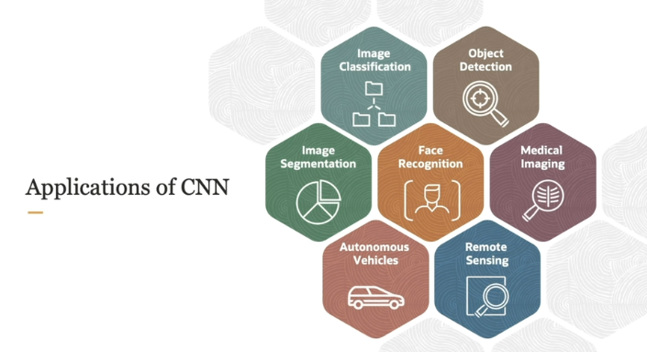

**1. Image Classification:**

* **What it is**: CNNs are commonly used to classify images. For example, you could train a CNN to look at an image and decide whether it contains a **cat or a dog**.
* **How it works**: The CNN looks for patterns in the image, like the shapes of ears, fur texture, or eyes, to decide which object is in the picture.

**2. Object Detection:**

* **What it is**: In object detection, CNNs can identify and **locate objects in an image** by drawing **bounding boxes** around them.
* **How it works**: The CNN detects multiple objects (like a car, person, or dog) and tells us exactly **where** each object is located in the image.

**3. Pixel-Level Segmentation:**

* **What it is**: CNNs can go beyond detecting objects and classify **each pixel** in an image. This is called **segmentation**, where different parts of the image are labeled to represent different objects or regions.
* **How it works**: For example, in a medical scan, CNNs can label each pixel to show different tissues or organs, like where the tumor is located.

**4. Face Recognition:**

* **What it is**: CNNs are used for **recognizing faces**. They can identify or verify individuals based on their facial features.
* **How it works**: For example, when you unlock your phone with **facial recognition**, a CNN analyzes key facial features like the distance between your eyes or the shape of your nose to confirm your identity.

**5. Medical Image Analysis:**

* **What it is**: CNNs are widely used in **analyzing medical images**, such as X-rays, MRIs, or CT scans, to detect tumors or diagnose diseases.
* **How it works**: For example, CNNs can help radiologists identify and classify abnormalities like tumors or broken bones, assisting in faster diagnosis.

**6. Self-Driving Cars:**

* **What it is**: CNNs are essential in **self-driving cars** to help them recognize traffic signs, pedestrians, and other vehicles on the road.
* **How it works**: The CNN processes the car’s camera feed to help the car **understand** what’s happening around it, like identifying a stop sign or detecting nearby cars, so it can make safe driving decisions.

**7. Satellite Image Analysis:**

* **What it is**: CNNs are applied to **satellite images** for tasks like classifying land areas (forests, urban areas) or monitoring environmental changes.
* **How it works**: For example, CNNs can be used to analyze satellite data to detect deforestation or track urban growth over time.